1. Open the UG installation folder, the path should be: Program Files -> Siemens -> NX 10.0 -> MACH -> resource -> postprocessor.
2. Copy the files ‘CARVERA.DEF’, ‘CARVERA.PUI’, and ‘CARVERA.TCL’ into the ‘postprocessor’ folder.
3. Locate the ‘template_post.dat’ file in the ‘postprocessor’ folder and open it using Notepad.
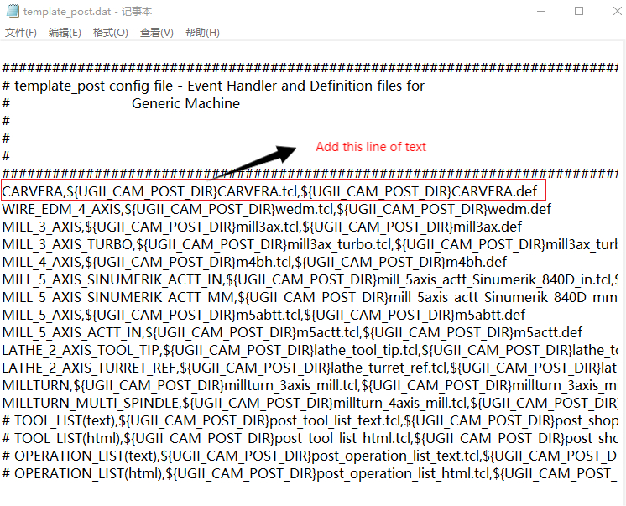

- Open the NX project file, right-click on the desired program file, select "Postprocess," and after configuring the settings as shown in the picture, click "OK" to generate the toolpath file. 